EM314 - NUMERICAL METHODS ASSIGNMENT - 3

Hisni Mohammed M.H.

E/15/131

**Implementation**

1. **(a)**

**OCTAVE code ( LagrangeInterpolant.m )**

pkg load symbolic;

function LagrangeInterpolant( X , Y )

syms x

Px=0;

len = length(X);

for i=1:len

l= x^0;

for j=1:len

if i!=j

l = simplify(( l*( x-X(j) )/( X(i)-X(j) ) ));

endif

endfor

Px = Px + l*Y(i);

endfor

Px = simplify(Px)

hold on;

ezplot(Px)

plot(X,Y,'ob')

endfunction

**(b) OCTAVE code ( Q2.m )**

X = [0 1/2 1];

Y = [0 1/4 1];

LagrangeInterpolant(X, Y);

**Output of the code**

>> Q2

Px = (sym) x2

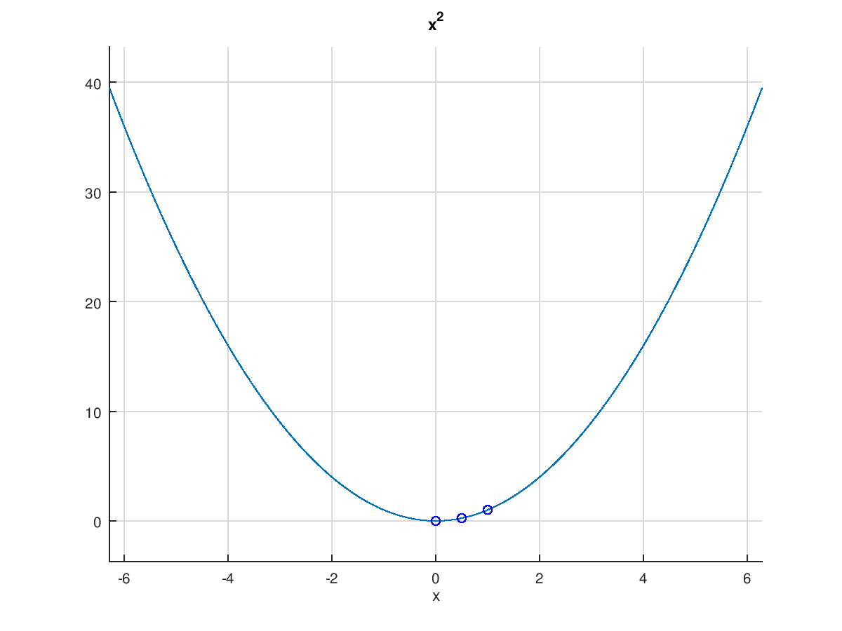

Expected answer which P(x) = x2 is obtained.

1. **(b) OCTAVE code ( Q3.m )**

pkg load symbolic;

syms x

X = -10:2:0;

Y = [19.1 20.7 28.2 28.7 29 29.1];

Px=0;

len = length(X);

for i=1:len

l= x^0;

for j=1:len

if i!=j

l = simplify(( l*( x-X(j) )/( X(i)-X(j) ) ));

endif

endfor

Px = Px + l*Y(i);

endfor

Px = simplify(Px)

hold on;

grid on;

ezplot(Px)

plot(X,Y,'ob')

Temp = double(subs(Px,x,-7 ))

p1 = simplify(diff(Px,x));

p2 = simplify(diff(p1,x))

points = real( double(solve(p2==0,x) ) )

x0 = -9:0.2:-1;

y0 = double(subs(p1,x,x0));

y1 = double(subs(p1,x,points));

plot(x0,y0)

plot(points,y1,'ob')

**Output of the code**

>> Q3

Px = (sym)

- (53/7680)*x5 - (299/1920)*x4 - (2263/1920)*x3 - (1711/480)*x2 - (7/2)*x1 - (291/10)

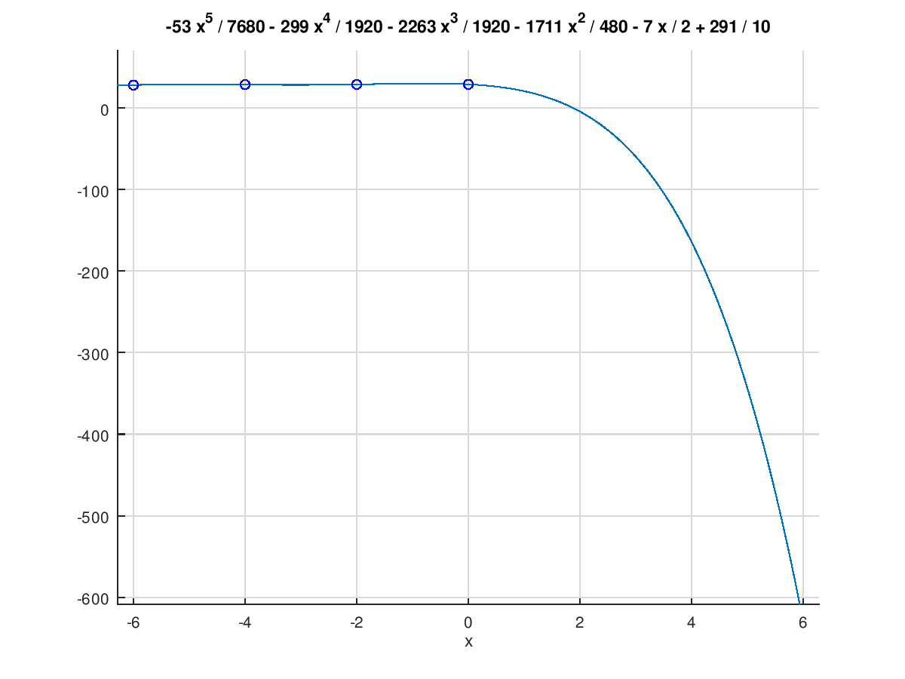

Temp = 25.291

p1 = (sym) -(53/1536)*x4 – (299/480)*x3 – (2263/640)*x2 – (1711/240)*x – (7/2)

p2 = (sym) -(53/384)*x3 – (299/160)*x2 – (2263/320)*x – (1711/240)

points =

-4.0723

-1.6154

-7.8519

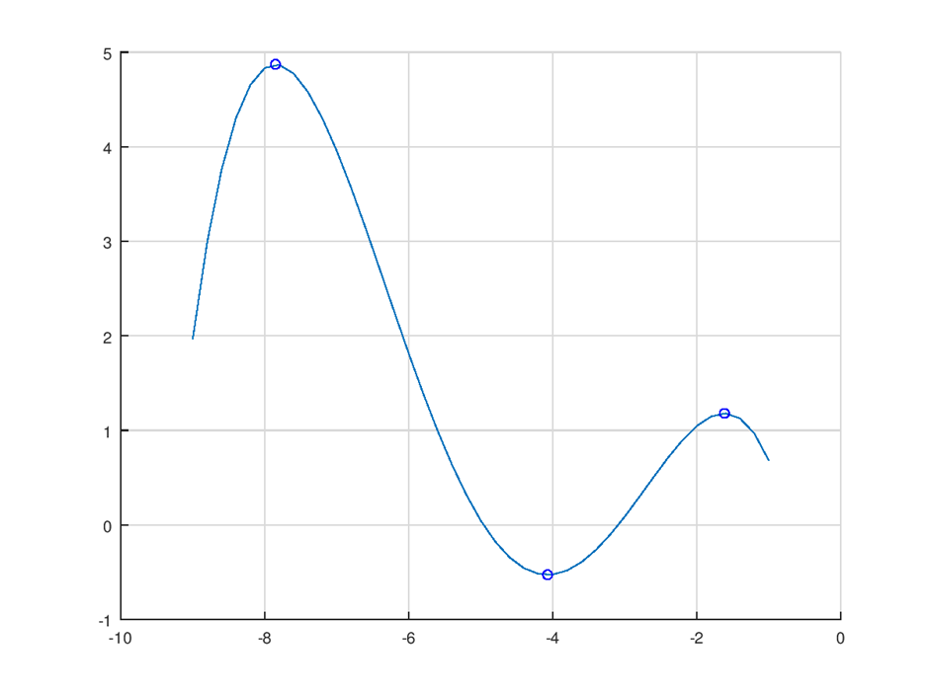Graph of $\frac{dT}{dz}$,

1. Lagrange interpolating polynomial P(x),

P(x) = - (53/7680)*x5 - (299/1920)*x4 - (2263/1920)*x3 - (1711/480)*x2 - (7/2)*x1 (291/10)

1. Temperature at depth 7m of the lake is 25.291 C.

When comparing with the values it is a valid answer.

1. The thermocline locates at the maximizer of $\frac{dT}{dz}$,

Critical points of $\frac{dT}{dz}$ are given by $\frac{dT^{2}}{d^{2}z}=0$

$\frac{dT}{dz}= -(53/1536)*x^{4}– (299/480)*x^{3} – (2263/640)*x^{2} – (1711/240)*x – (7/2)$

$\frac{dT^{2}}{d^{2}z}= -(53/384)*x^{3} – (299/160)*x^{2} – (2263/320)*x – (1711/240)$

Therefore, critical points are (-1.6154), (-4.0723), (-7.8519).

But by the graph $\frac{dT}{dz}$ maximum occurs at x= (-7.8519)

Therefore Thermocline locates at -7.8519m.